Kaiwen

Observations and Playtester Comments

# In-Game Observations

[Your thoughts as you watch the testers play]

* Graphics look really good
* Still need backstory
* Otherwise, everything looks super good

# In-Game Questions

Why did you make that choice? (why did you go into houses?)

* I need to talk to people and there is an entrance

What did you think that would do? (what would interacting with people do?)

* Get a higher level

What is confusing for you?

* There is no outcome after each conversation

# Postgame Questions

[Questions you ask the testers as they have played]

* Did you like the game?
  + Yes
* Was it too much for a non-native English speaker to understand?
  + It did take me longer to understand what was going on, and I felt a little pressure since I did not know what all of the words meant

## General Questions

What was your ﬁrst impression?

* The music is really good

How did that impression change as you played?

* It didn’t change

Was there anything you found frustrating?

* put a little map to know where we are

Did the game drag at any point?

* no

Were there particular aspects that you found satisfying?

* The conversations were very funny

What was the most exciting moment in the game?

* When the answer is related to life, don’t want to keep listening to them talk

Did the game feel too long, too short, or just about right?

* Too short

## Formal Elements

Describe the objective of the game.

* Interact with people in the society

Was the objective clear at all times?

* yes

What types of choices did you make during the game?

* Go into buildings, go out, choose who to talk to

What was the most important decision you made?

* They all are weighted the same right now

What was your strategy for winning?

* NA

Did you ﬁnd any loopholes in the system?

* There is a bug on the guard, FIX

How would you describe the conﬂict?

* NA because no backstory on screen yet

In what way did you interact with other players?

* NA

Do you prefer to play alone or with human opponents?

* Play alone

What elements do you think could be improved?

* It’s pretty good, so none

## Dramatic Elements

Was the game’s premise appealing to you?

* yes

Did the story enhance or detract from the game?

* enhance

As you played, did the story evolve with the game?

* yes

Is this game appropriate for the target audience?

* yes

On a piece of paper, graph your emotional involvement over the course of the game.

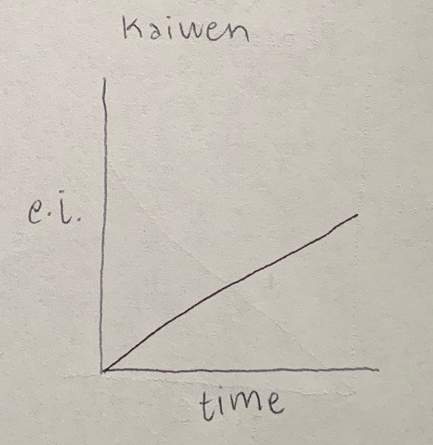

Did you feel a sense of dramatic climax as the game progressed?

* no

How would you make the story and game work better as a whole?

* Add more conversations

## Procedures, rules, interface, and controls

Were the procedures and rules easy to understand?

* yes

How did the controls feel? Did they make sense?

* yes

Could you ﬁnd the information you needed on the interface?

* yes

Was there anything about the interface you would change?

* Put a map

Did anything feel clunky, awkward, or confusing?

* No

Are there any controls or interface features you would like to see added?

* Put a map

## End of Session

Overall, how would you describe this game’s appeal?

* It can be a healing session for depression and they can randomly talk to people and not have social anxiety

Would you purchase this game?

* yes

What was missing from the game?

* An ending

If you could change just one thing, what would it be?

* Add an ending

Who do you think is the target audience for this game?

* Socially awkward people

If you were to give this game as a gift, who would you give it to?

* myself

# Revision Ideas

[Ideas you have for improving the game]

* In next versions of the game, add a little map to tell the player where everything is
* Need to have better radius issues, but cannot be helped rn